Tim Fang

2021-Nov-21

Foundations of Programming (Python)

Assignment 06

Functions and Classes

# Introduction

This document will describe what I learned from Module 06, outline the steps I took to complete the sixth assignment, and summarize some challenges. For this assignment, I will continue using Spyder to modify a CD inventory program. Using a solution to last week’s assignment, I will modify its script to add more functions and describe them with docstrings. I will execute the program in both Spyder and Terminal.

# Program Planning

I began this week’s assignment by reviewing the starter script, how it’s organized, and the TODO items. I realized there are helpful toggles next to line numbers that ‘hide’ sections of code. Despite that, I found it more helpful to open an empty window, write out each class and its functions, and list the TODOs from the main program as well as their final locations in their respective class/function. That kind of process mapping helped keep my focus on the TODOs.

I began at the bottom with choice ‘s’ and its code to save to file. The TODO at the function *write_file(file_name, table)* made the most sense. Second, I addressed choice ‘d’ and its code to delete a CD. The TODO at the class *DataProcessor* was the next logical place. Finally, I tackled choice ‘a’ and its two-part TODOs. One option was to move user input (# 3.3.1) into its own function in class *IO* and move table processing (# 3.3.2) into its own function in class *DataProcessor*. I decided on a simpler option, combining them into one function. I did that for a couple of reasons. First, the TODOs didn’t specify which class to place them, just that they needed to be moved into function. Second, table processing (# 3.3.2) is a kind of ‘output’ in my mind. Of course, I could be wrong.

The second option was easier to accomplish without passing data between functions. I tried the first option briefly and realized it created more frustration because we haven’t covered that functionality this week. In the end, the simpler option worked when tested.

# Final Script

The following figures show the program working as I cycled through each option. I created a blank CDInventory.txt file in the program’s folder so there wouldn’t be an error message, ‘FileNotFoundError: [Errno 2].’

Figure 1 shows option ‘L’ at the start of the program with a preexisting .txt file in the program’s folder.

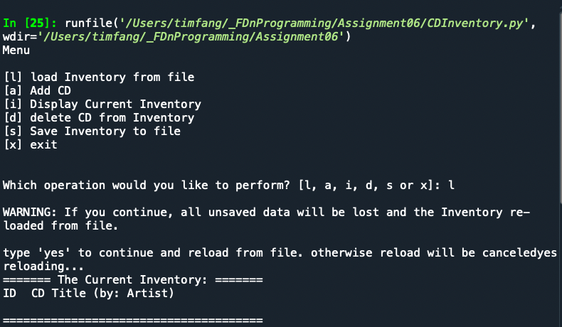

Figure - CDInventory program, option 'L'

Figure 2 shows option ‘A’ after entering the 2nd CD to inventory.

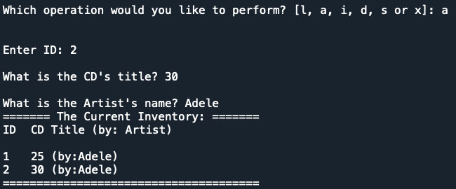

Figure - CDInventory program, option 'A'

Figure 3 shows option ‘I’ and displays current inventory again.

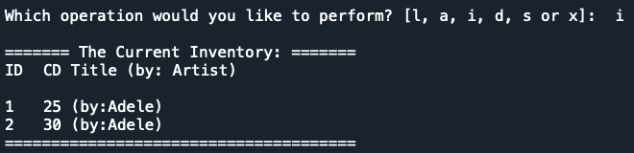

Figure - CDInventory program, option 'I'

Figure 4 shows option ‘D’ and the deletion of ID row 2.

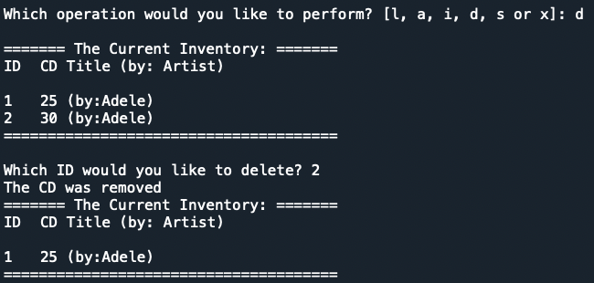

Figure - CDInventory program, option 'D'

Figures 5 & 6 show options ‘S’ and ‘L’ when the inventory is saved to and loaded from file.

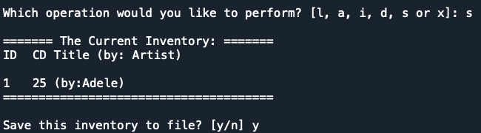

Figure - CDInventory program, option 'S'

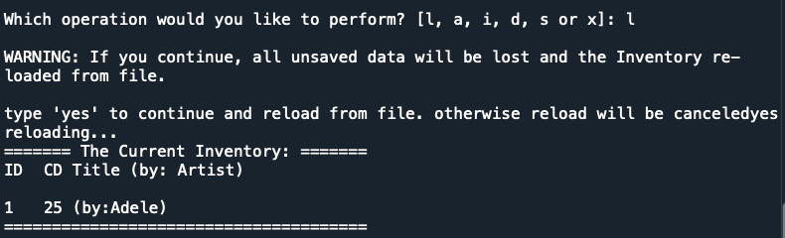

Figure - CDInventory program, option 'L'

Figure 7 shows the text file contents.



Figure - CDInventory program, txt file contents

The following figures will show the same options in Terminal.

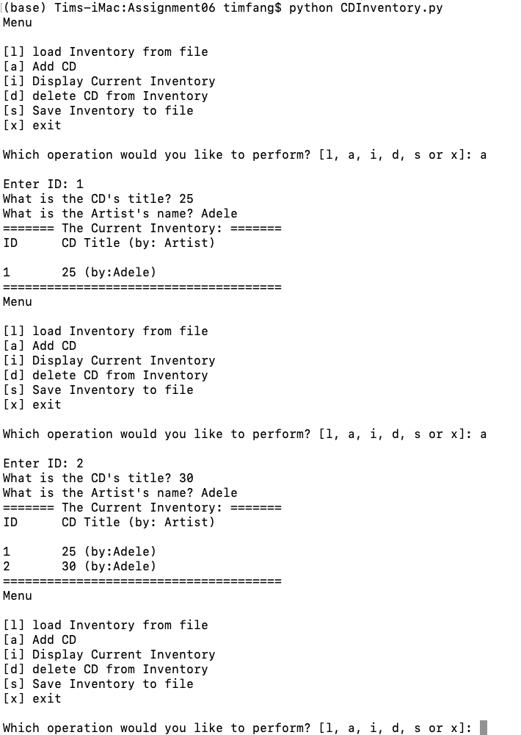

Figure - CDInventory program (Terminal), option 'A'

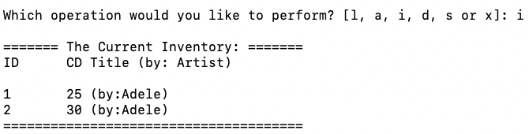

Figure - CDInventory program (Terminal), option 'I'

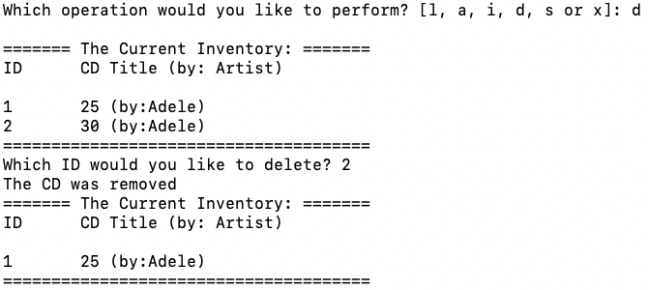

Figure - CDInventory program (Terminal), option 'D'

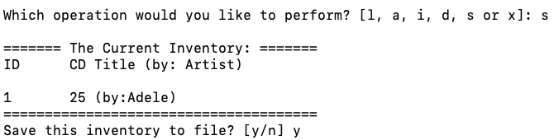

Figure - CDInventory program (Terminal), option 'S'

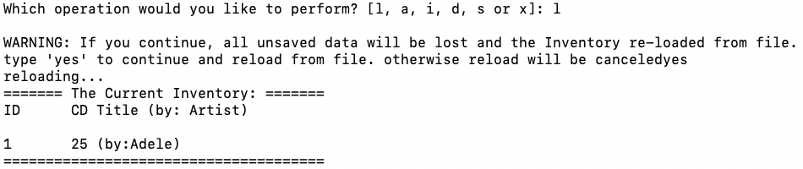

Figure - CDInventory program (Terminal), option 'L'

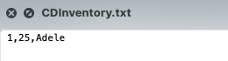

Figure - CDInventory program (Terminal), txt file contents

# Summary

With each week, I’m less surprised by how many times I have to reread the material. When I find that a topic doesn’t make sense or need more explanation, I end up taking a break and coming back to it. Additionally, I have to search online to fill in the gaps. I understand that everyone taking this course has a different background and foundation level. It feels more frustrating for me because I started with a blank canvas. For example, the following link does offer a good reference for old and new styles of working with the format() function (<https://pyformat.info>). However, it lacks the explanation I need from a more basic level. I was able to find what I needed from the following link in order to understand this week’s labs (<https://towardsdatascience.com/format-function-in-python-98ed34e0a70e>). Definitely trying my best and spending most if not all of my available time to keep up. I’m looking forward to this course’s conclusion.

# Appendix

As requested, I’ve included a link to my repository on GitHub for this assignment.

<https://github.com/timsfang/Assignment_06>